We had to design a Tic Tac Toe game which is a simple game of 2 players where they have to fill in boxes and make a pattern, whoever makes the pattern first, wins the game. We implemented this idea by using Object Oriented Programming.

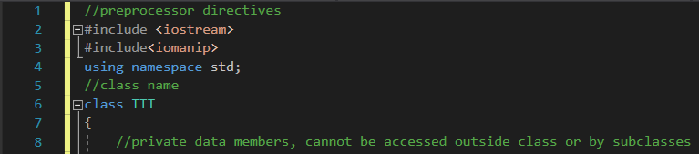

A class TTT was made which had some private data members and public member functions.

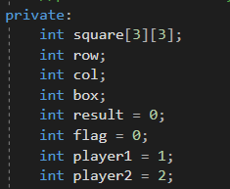

We used a 2D 3x3 matrix for designing the game as per the question requirements. The entry of player 1 is placed with a 1 and a 2 is placed when its player 2’s turn. Then the pattern is analyzed by using some logical commands.

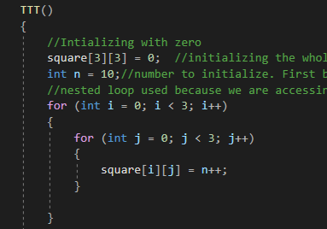

Firstly, we initialized our 2D array with 0 so it does not take any garbage value. Then, we used a nested for loop to place numbering in each box from 10 to 18 and each player will name the box in which they want to place their turn.

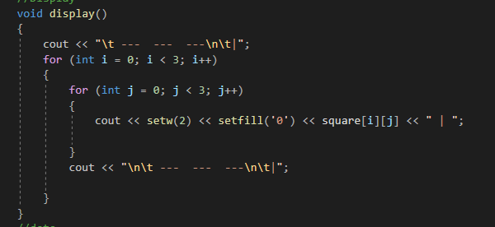

The display function here is only printing the tic tac toe pattern to the user so they know which box to place their turn in. As we are dealing with a 2D array, we use a nested for loop to do this. The setw function sets the width of the matrix and the setfill matrix fills the gap of the matrix with 0’s. These are two are taken from the library <iomanip>. This is what this display() function is doing:

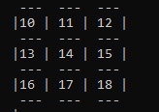

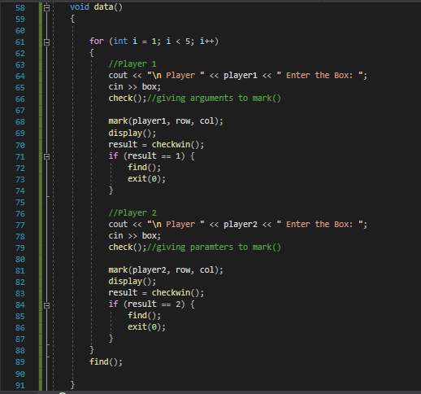

The data() function over here basically asks the user when it’s their turn and takes their entry as input and displays them back what they entered. For instance, on line #65, you can see the user enters the box number which on the back hand gives us the row and column of that box which is then passes as parameters to the mark function which is called. Mark function places a 1 if it was player 1’s turn or a 2 if it was player 2’s turn. Then a display() function on line #69 is used to display that user’s turn. After every turn of the player, the checkwin() function is called in a loop which basically checks if that user has won or not, if the user won, it simply displays a message and exits the screen. If not, it keeps checking.

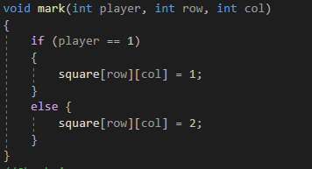

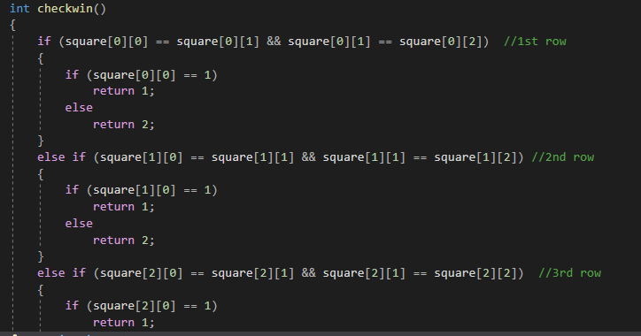

The checkwin() function, as already been told, checks after each turn if that user has won or not, in order to do that, it compares the pattern in every row column and diagonal.

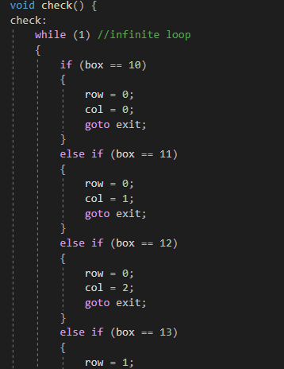

An infinite loop is made over here. Whenever a user enters the box number seen earlier in the data() function, This loop assigns the value of row and column and then goes to the exit line which again redirects in to the checkwin() function to see, after entering the box, if the user has won or not. It basically inserts the value obtained from checkwin() function to the final result.

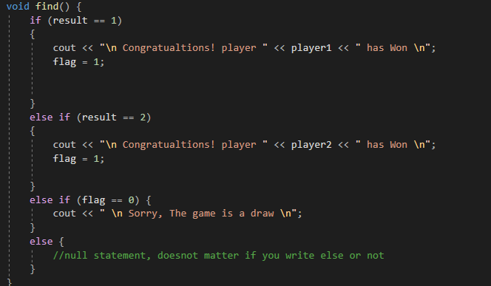The use of this function comes at the very end, when from the infinite loop we gave result a value after checking from the checkwin() function, we know player 1 enters a 1 and player 2 enters a 2, so if a pattern of 1 was obtained, result is given a value of 1 and player 1 wins, same is the case for player 2, if there are no complete patterns observed, it declares a draw.

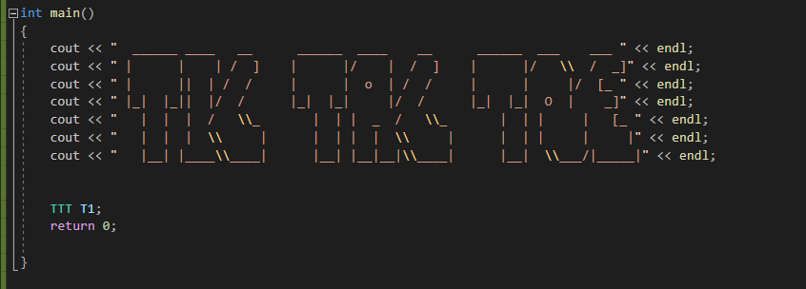

We only made an object in the driver function which automatically called constructor and after that functions are automatically called.

Let’s see how to play Tic tac toe!!

